**Fake News Detection in Bangla Using Machine Learning, Deep Learning.**



**A COMPLETION OF THE DEMANDS FOR THE M.SC. ENGINEERING DEGREE IN INFORMATION AND COMMUNICATION TECHNOLOGY THROUGH A DISSERTATION**

Submitted By

**Ahsanul Kobir Rashed**

**ID:22209037**

Session: 2021-2022

Department of Information and Communication Technology

Comilla University, Bangladesh

**Submission**: Feb, 2025

**ABSTRACT**

Online social media networks have evolved into complex platforms for news consumption. The increase in confusing information from traditional media outlets, such as social networking websites, news blogs, and various online platforms, has made it challenging to identify reliable news sources. This situation has heightened the demand for computer applications that can clarify the reliability of information on social media.The spread of false information on social media is often more extensive than in traditional media outlets. The circulation of inaccurate Bengali information on social media has become a significant issue, as it can threaten national sovereignty. Several studies using Natural Language Processing (NLP) and Deep Learning have been conducted to detect fake news in Bangla.In our project, we developed an NLP method using a "Random Forest" machine learning model, based on decision trees. We propose a system that detects fake information from online sources by comparing true and false news. Additionally, we created various NLP models, including Logistic Regression (LR), Multinomial Naive Bayes (MNB), K-Nearest Neighbors (KNN), Decision Trees (DT), and Support Vector Machines (SVM), including Linear SVM and RBF-SVM. We also employed advanced Neural Network algorithms such as Convolutional Neural Networks (CNN), Bi-directional Long Short-Term Memory (Bi-LSTM), Gated Recurrent Units (GRU), Long Short-Term Memory (LSTM), CNN combined with GRU, Recurrent Neural Networks (RNN), and CNN combined with LSTM, all of which performed well in identifying fraudulent information.In our research, we tested all methods, including RBF-SVM, Linear SVM, KNN, LR, DT, MNB, and Random Forest Classifier (RFC), on the same dataset used for training and testing. Our results showed that the Decision Tree model outperformed the other models significantly.

**INDEX**

|  |  |
| --- | --- |
| **Contents** | **Page** |
| Abstract……………………………………………………………………... | ii |
| List of Tables ……………………………………………….......................... | v |
| List of Figures ………………………………………………………………. | vi |
| List of Symbol & Abbreviation….......……...……….......................................... | vii |
| **CHAPTER 1: INTRODUCTION………………………………………………** | **1-4** |
| 1.1 Motivation …………………………………………………………………… | 3 |
| 1.2 Purpose of Research ………………………………………………………. | 4 |
| 1.3 Objective and Contributions …………………………………………… | 4 |
| **CHAPTER 2: BACKGROUND STUDY ……………………………………** | **5-10** |
| 2.1 Features & Fake News …………………………………………………. | 6 |
| 2.1.1 Describe of False News ……………………………………………. | 6 |
| 2.1.2 Fake news in traditional Media ……………………………………… | 7 |
| 2.1.3 Fake News on Online Media …………………………………… | 8 |
| 2.2 Fake News Detection …………………………………………………… | 8 |
| 2.2.1 Problem Describe ……………………………………………………… | 8 |
| 2.2.2 Feature Extraction …………………………………………………… | 9 |
| 2.2.3 News Content Features …………………………………………… | 9 |
| 2.2.4 Features of the Social Context ………………………………………… | 10 |
| **CHAPTER 3: LITERATURE REVIEW……………………………….........** | **11-16** |
| 3.1 Associated Works …………………………………………………………… | 12 |
| 3.2 Related Areas ……………………………………………………………… | 12 |
| 3.2.1 Classification of Speculation ……………………………………… | 13 |
| 3.2.2 Identification of clicking bait ………………………………… | 13 |
| 3.2.3 Diagnosis of Spammers and Bots …………………………… | 13 |
| 3.3 Deep Learning ………………………………………………………………… | 13 |
| 3.4 Machine Learning ………………………………………………………………… | 14 |
| 3.3.1 **Core Mechanisms of Machine Learning** ………………………… | 15 |
| 3.5 Research Summery ……………………………………………………………… | 16 |
| 3.6 Challenges ………………………………………………………………………… | 26 |
| **CHAPTER 4: THE METHODOLOGY OF RESEARCH………………………….** | **17-31** |
| 4.1 Architecture Overview …………………………………………………… | 18 |
| 4.1.1 Data Gathering & Synopsis ……………………………… | 19 |
| 4.1.2 Data Preprocessing ……………………………………………… | 21 |
| 4.1.3 Feature Extraction ………………………………………………… | 22 |
| 4.1.4 Data Split …………………………………………………………………… | 23 |
| 4.1.5 Train Model ……………………………………………………………… | 24 |
| 4.1.6 Classifier ………………………………………………………………… | 24 |
| 4.2 Model Design ………………………………………………………………… | 26 |
| 4.2.1 Machine Learning Model ………………………………………… | 26 |
| 4.2.2 Deep Learning Model ………………………………………………… | 39 |
| **CHAPTER 5: RESULT & DISCUSSION…………………………………** | **32-38** |
| 5.1 Assessment of Performance ……………………………………………… | 33 |
| 5.2 Accuracy & Validation Loss Graph ……………………………………… | 36 |
| 5.3 Discussion ……………………………………………………………………… | 38 |
| **CHAPTER 6: Conclusion and Upcoming Research………………………** | **39-40** |
| 6.1 Conclusion ……………………………………………………………… | 40 |
| 6.2 Recommendation …………………………………………………… | 40 |
| 6.3 Future Work …………………………………………………………… | 40 |
| **REFERENCES ……………………………………………………………** | **41-47** |

**Tables List**

|  |  |  |
| --- | --- | --- |
| Table No | Table Title | Page No |
| Table 4.1.2 | Description of Dataset Column | 19 |
| Table 4.1.3 | Fake dataset Preview | 20 |
| Table 4.1.4 | Real Dataset Preview | 20 |
| Table 5.1 | Recall and F1, Accuracy, precision Score features of ML, DL | 34 |

**Figures List**

|  |  |  |
| --- | --- | --- |
| Figure No | Figure Title | Page No |
| Figure 2.1 | Fake news on social media: from Features to identification. | 6 |
| Figure 3.3 | Structure of Deep Learning | 14 |
| Figure 3.4 | Structure of Deep Learning | 15 |
| Figure 4.1 | Process flow of Bangla Fake News Recognize | 18 |
| Figure 4.1.1 | Representation of Dataset | 20 |
| Figure 4.1.2 | Data Preprocessing flow | 21 |
| Figure 4.1.3 | Data Train Process Flow | 27 |
| Figure 4.1.5 | Feature Extraction with TF-IDF | 25 |
| Figure 4. 1.4 | Word cloud for True News | 2 |
| Figure 4.1.6 | Word cloud for False News | 29 |
| Figure 4.2.1 | Structure of Decision Tree | 27 |
| Figure 4.2.2 | Structure of Random Forest | 28 |
| Figure 4.2.3 | Structure of Decision Tree | 30 |
| Figure 5.1.1 | Chart preview of F-score, Precision, Accuracy, Recall | 35 |
| Figure 5.2.2 | CNN+GRU Model AUC graph | 36 |
| Figure 5.2.3 | CNN+LSTM Model Loss Graph | 36 |
| Figure 5.2.4 | RNN model Loss Graph | 37 |
| Figure 5.2.5 | CNN model Loss Graph | 37 |
| Figure 5.2.6 | LSTM model Loss Graph | 37 |

**SYMBOLS AND ABBREVIATION LIST**

|  |  |
| --- | --- |
| Symbols | Abbreviation |
| KNN | K-Nearest Neighbors |
| ML | Machine Learning |
| DL | Deep Learning |
| CNN | Convolution Neural Network |
| AI | Artificial Intelligence |
| NLP | Natural Language Processing |
| LR | Logistic Regression |
| DT | Decision Tree |
| RF | Random Forest |
| SVM | Support Vector Machine |
| KNN | K-Nearest Neighbors |
| ML | Machine Learning |

Chapter- 1

**INTRODUCTION**

**Introduction**

As our lives increasingly revolve around online communication across a variety of social media platforms, more and more people are turning to these networks for information rather than relying on traditional media. This shift in behavior is driven by the advantages that social media offers:

(i)Information on these platforms is often more up-to-date and cost-effective than conventional sources such as newspapers or television, and (ii) it is easier to share, discuss, and clarify information with friends and others in these networks. For example, in 2016, 62% of US adults used social media for news, up from 49% in 2012.[1] Social media has now become the primary source of information for many people, surpassing traditional television.[2]. Despite the convenience of social media, the accuracy of information shared on these platforms is generally lower than that of traditional media. The low cost and ease of disseminating information online have led to a significant increase in fake news, that is, intentionally misleading stories created for financial or political gain. By the end of the 2016 US presidential election, more than a million tweets were related to fake news.[3] This trend was significant enough that the term “fake news” was named the Macquarie Dictionary’s 2015 Word of the Year. The widespread dissemination of fake news has serious consequences for individuals and society. First, it damages the credibility of the information ecosystem. For example, during the 2016 US presidential election, some of the most widely shared fake news stories outperformed mainstream information on social media. [4] Fake news is intentionally misleading and is often used as a tool for propaganda or political influence. For example, Russia has been accused of using fake profiles and bots to spread fabricated stories.[5]

(iii) false news skews public perception and reactions to actual news, creating confusion and skepticism that make it difficult for individuals to differentiate between truth and falsehood. [6]. To mitigate these harmful effects, it is crucial to develop tools that can automatically detect fake news on social media, benefiting both the public and the news ecosystem. For example, fake news often misuses factual evidence to support false claims [10]. The World Wide Web has transformed information sharing and communication, making knowledge more accessible and tasks easier. However, social media has also allowed ordinary users to create and manipulate information easily. [11]. In today's world, social media plays a dominant role in our daily lives, and fake news has become a widespread issue that threatens various sectors, including business, politics, economics, education, and democracy. Although fake news is not a new phenomenon, the increasing dependence on social media has made people more vulnerable to believing and sharing it. As a result, distinguishing between credible and misleading news has become more challenging, leading to conflicts and misunderstandings. Manually identifying fake news is difficult and often requires specialized expertise. [12]. Social media has changed the way news is produced, distributed, and consumed, creating both opportunities and challenges. One major concern is the rising of social media as a platform for misinformation, which undermines the reliability of the entire news ecosystem. Unlike traditional media, anyone can act as a news provider on social media without any initial costs. [13]. This has made social media a focal point for researchers studying the creation and detection of fake news, as it provides a rich source of contextual data related to fake stories. The large user base of social media makes it a prime environment for spreading fake news, which refers to false stories intended to mislead readers and influence political outcomes. Often created for financial or political gain, the circulation of misinformation disguised as legitimate news has become increasingly common. [14], Seventy percent of people are concerned about the harmful use of misinformation. [20].

Major social media companies, such as Facebook and Twitter, have implemented measures to identify and reduce the spread of fake news on their platforms. Significant events, including the 2016 U.S. presidential election and Brexit, have been heavily targeted by fake news campaigns. [4]. Fake news extends beyond politics and can influence various sectors. For example, a false story claiming an asteroid held $10 quadrillion in precious metals was circulated to manipulate Bitcoin prices. [15]. The spread of misinformation in U.S. politics, especially during the 2016 election, raised significant concerns. [16]. To tackle the problem of fake news, researchers have created several detection methods. One effective approach involves developing a multi-class dataset for fake news and applying machine learning techniques to classify the information. An example of such an initiative is the Fake News Challenge (FNC). [14]. On platforms like Kaggle, datasets of real and fake news are used to train machine-learning models. This study proposes a method to distinguish between fake and legitimate news using natural language processing (NLP) text vectorization and supervised machine learning techniques. The model evaluates articles based on their content, statements, sources, and titles, using a carefully labeled dataset. Feature selection methods are then applied to optimize accuracy [18]. The motive is to create a model which can identify and categorize fake news, which can be integrated into various systems. The final product will analyze unseen data and provide results, offering a practical tool for detecting fake news [19].

* 1. **Motivation**

The fast spread of fake news has risen as one of the foremost squeezing challenges around the world, frequently fueling savagery and animosity. The influence of social media and the internet is widespread, leading individuals to unknowingly share news stories with enticing headlines, often without verifying their accuracy. In today’s digital age, anyone with access to a computer and keyboard can create and disseminate false information across social platforms, gaining financial benefits through their websites without considering the potential harm caused by the misinformation. Many individuals are motivated by the number of reactions and shares their posts receive, and they may not be concerned if their content misleads or harms others. In countries like Bangladesh, a large portion of internet users lack adequate digital literacy. During the COVID-19 pandemic, for instance, many citizens turned to online platforms for health-related information. Misinformation spread quickly, with one of the first false claims in Bangladesh suggesting that consuming Thankuni roots (Indian pennywort) and praying Bismillah (in Allah’s name) daily would protect against the virus [7]. Additionally, rumors circulated on WhatsApp and Facebook claiming that human sacrifices were required to complete the Padma Bridge, leading to the wrongful suspicion of child kidnappers and subsequent mob killings [8]. In 2012, a Facebook post falsely accused a Buddhist of desecrating the Quran in Ramu, inciting a mob of about 25,000 people to destroy monasteries and homes, even though the accusation was baseless [9]. Recently, there have been incidents where individuals posted on social networks accusing their partners of domestic abuse, only for investigations to reveal that no such incidents occurred. Similarly, fake requests for help from nonexistent individuals or groups have also been reported. To address the spread of such misleading information, we propose a machine learning-based strategy using multiple classifiers to more effectively detect fake news. 1.1 Motivation  
The fast spread of fake news has emerged as one of the tough challenges around the world, often fueling violence and aggression. The influence of social media and the internet is widespread, leading individuals to unknowingly share news stories with enticing headlines, often without verifying their accuracy. In today’s digital age, anyone with access to a computer and keyboard can create and disseminate false information across social platforms, gaining financial benefits through their websites without considering the potential harm caused by the misinformation. Many individuals are motivated by the number of reactions and shares their posts receive, and they may not be concerned if their content misleads or harms others. In countries like Bangladesh, a large portion of internet users lack adequate digital literacy. During the COVID-19 pandemic, for instance, many citizens turned to online platforms for health-related information. Misinformation spread quickly, with one of the first false claims in Bangladesh suggesting that consuming Thankuni roots (Indian pennywort) and praying Bismillah (in Allah’s name) daily would protect against the virus [7]. Additionally, rumors circulated on WhatsApp and Facebook claiming that human sacrifices were required to complete the Padma Bridge, leading to the wrongful suspicion of child kidnappers and subsequent mob killings [8]. In 2012, a Facebook post falsely accused a Buddhist of desecrating the Quran in Ramu, inciting a mob of about 25,000 people to destroy monasteries and homes, even though the accusation was baseless [9]. Recently, there have been incidents where individuals posted on social networks accusing their partners of domestic abuse, only for investigations to reveal that no such incidents occurred. Similarly, fake requests for help from nonexistent individuals or groups have also been reported. To address the spread of such misleading information, we propose a machine learning-based strategy using multiple classifiers to more effectively detect fake news.

**1.2 Purpose of Research**

This research aims to provide a comprehensive overview of various models used for deception detection in the field of natural language processing (NLP) within machine learning. It seeks to assist future researchers in identifying detection models that align with the recognition models they are developing or in pinpointing under-researched classification algorithms. The study intends to present an accessible summary of previous research datasets, commonly used classification algorithms, baseline classifications for comparison, and the performance of different classification methods. The implementation will focus on detecting false news in Bangla using machine learning, deep learning, and transformer-based approaches. A custom dataset will be created by extracting and processing information from multiple newspaper sources. Experiments will be conducted in distinct phases, where news will be classified as either fake or real using various machine learning, deep learning, or transformer algorithms. The accuracy of these algorithms will be thoroughly evaluated.

**1.3 Objectives and Contributions**

Fake news has the potential to significantly impact entire communities. Over the years, researchers have strived to develop automated systems capable of identifying false news and alerting readers effectively. While numerous advanced models exist for detecting fake news, most are designed for English language content, with very few tailored for Bangla. **The primary objective of this research is to create an advanced model capable of detecting false or misleading information in the Bengali language**. By leveraging modern techniques such as machine learning and natural language processing, this model will enable readers to verify the authenticity of the content they encounter, whether in articles or headlines. To achieve this, the model will analyze individual words and sentences, filtering out unnecessary words or punctuation marks that do not contribute to the detection process. **Pre-processing techniques specific to Bangla will be employed, addressing the current lack of tools for such tasks in the language. This research will provide a valuable resource for future researchers working with Bangla and has the potential to benefit not only the nation but also Bangla speakers worldwide**. By contributing to the fight against misinformation, this work aims to serve humanity and help prevent the spread of violence or unrest caused by fake news.

Chapter- 2

**BACKGROUND STUDY**

**2.1 Features & Fake News**

This section explores more complex aspects of social media, along with fundamental sociological and psychological theories associated with fake news. Initially, we’ll look at many definitions of fake news and define certain phrases that are frequently used interchangeably with false information. Following this, we will highlight key features of fake news in traditional media and identify emerging patterns observed on social media platforms.

**2.1.1 Describe of False News**

Since the printing press was created in 1439, fake news has been around for nearly as long as the general distribution of news [29].]. However, there is no universally accepted definition of "fake news." To address this, we first examine and assess some commonly used definitions in existing literature before proposing our own definition, which will be consistently applied throughout this study. Fake news is characterized as intentionally and verifiably false news articles designed to mislead readers [2]. Authenticity and aim are the two main points of emphasis in this definition. First, fraudulent information that can be shown to be inaccurate is included in fake news. Second, it is intentionally produced to mislead its audience.. Recent studies [22; 21; 24; 23] have widely adopted this interpretation. Broader definitions of fake news often focus on the authenticity of the content or its intent. For instance, some media outlets classify satirical news as fake news because the content is factually inaccurate, even though satire is primarily intended for entertainment and typically discloses its deceptive nature to the audience [25; 4; 26; 27]. Other sources use the term "fake news" more broadly [28], encompassing deliberate deception, hoaxes, and satirical content. In this article, we adhere to a narrower definition of fake news, which is formally defined as follows:

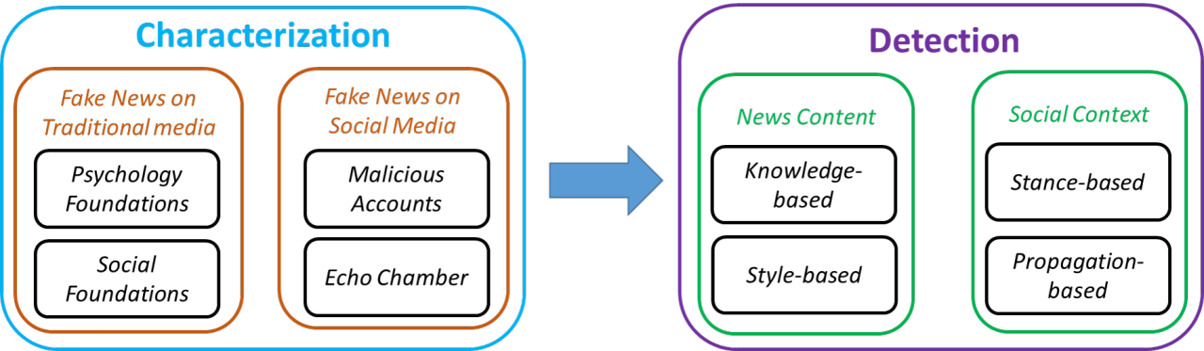

**Figure 2.1: Fake news on social media: from Features to Identification.**

entertainment-oriented and discloses its own deception to customers [25; 4; 26; 27]. Other literature refers to false news simply as fake news [28], encompassing significant deception, frauds, and satires. We use the restricted definition of false news in this article. This definition is formalized as follows:

**2.1.2 Fake News in Traditional Media**

The phenomenon of fake news is not new. Historically, the dissemination of unverified information has evolved across media platforms, from print and broadcast to digital and social media. Here, “traditional fake news” refers to misleading content circulated through pre-social media channels. This section explores cognitive and philosophical frameworks to analyze its impact on individual cognition and societal information ecosystems.

**Psychological Foundations of Misinformation Susceptibility**: Audiences are vulnerable to fake news due to two key psychological factors: (i) *Naive Realism*: Individuals perceive their own understanding of reality as objective, dismissing opposing views as illogical or prejudiced [38]; and (ii) Confirmation Bias: People are more likely to favor information that supports their preconceived notions.[33]. These ingrained cognitive biases make it challenging to discern fact from fiction. Once misinformation is internalized, corrections often fail—studies show that debunking false claims with facts may even reinforce misperceptions, especially among certain ideological groups [34].

**Sociological Drivers of Misinformation Spread**: At the societal level, fake news thrives through mechanisms tied to human behavior. *Prospect Theory* posits that decisions are influenced by perceived gains or losses relative to one’s circumstances [31,37]. This extends to social rewards, where individuals prioritize acceptance within their communities. *Social Identity Theory* [35,36] and *Normative Influence* [3,32] further explain how the pursuit of validation drives people to share “socially safe” content, even if false. Such dynamics can be modeled through game theory, framing news creation and consumption as strategic interactions between stakeholders [30].

**2.1.3 Fake News on Online Media**

Social media increases fake news through one of a kind components , in spite of the fact that numerous parallels with conventional publicity exist.

**Pernicious Performing Artists and Computerized Accounts:** Whereas most social media clients are veritable, pernicious profiles—including bots, cyborg accounts (human-bot crossovers), and trolls—proliferate due to moo account creation costs [41,42]. These robotized or semi-automated accounts effectively spread wrong accounts, misusing stage elements to control open conclusions [39,40].

**Reverberate Chambers and Fracture:** Social media disturbs conventional news curation, moving control from editors to calculations and clients. People frequently lock in with like-minded peers, making resound chambers that fortify existing convictions [43,44,45]. Rehashed introduction to particular thoughts cultivates acknowledgment, indeed if deceiving [46,47]. Over time, this homogenizes communities, lessening differing viewpoints and quickening deception spread [48].

**2.2 Fake News Detection**

Building on the characteristics outlined above, this section examines methodologies for defining and detecting fake news, leveraging insights from its psychological, sociological, and platform-specific dynamics.

**2.2.1 Problem Description**

This section explores the computational approach to detecting fake news on social networks. We begin by defining the key components of false news before formally describing the problem of fake news identification. Consider a news article, which consists of two main parts: the **Provider** and the **Information**. The Provider includes profile details about the author, such as their name, domain, age, and other relevant information. The Information comprises elements like the headline, text, images, and other content that represent the news piece. The goal of fake news detection is to determine whether a given news piece a*a* is false among n*n* users. This can be formalized as a function F:E→{0,1} *Where*

*F(a)={1, if an is bogus news, 0; else, F:E→{0,1}.If an is bogus news, F(a)={1,0, else 1}.*

The intended prediction model is denoted by FF in this case. Since fake news often involves biased or manipulated content, its identification is treated as a binary classification problem.

**2.2.2 Feature Extraction**

Unlike traditional news organizations like CNN, which primarily rely on news content to detect fake news, social networks offer additional socially relevant data that can aid in identifying false information. This section describes how to identify and highlight important aspects of news articles and their social context..

**2.2.3 News Content Features**

Features of news material explain the metadata associated with a news instance. Key properties include the domain, headline, content, images/videos, date, category, and more. The features of news content can be broadly categorized into language-based and visual-based attributes.

**Language-based Features**: Fake news articles are often crafted for political or economic gain, using sensational or inflammatory language designed to attract clicks or cause confusion. To detect fake news, linguistic features that capture writing styles and attention-grabbing headlines are useful. These features are extracted from text at various levels, such as letters, words, phrases, and entire documents.[49]

**Visual-based Features**: Visual elements like images and videos are analyzed to identify characteristics of fake news. For instance, fake images can be detected using user-level and tweet-level attributes. Visual features include brightness, contrast, similarity histograms, and biodiversity scores, while statistical features include metrics like photo count, multi-image ratio, and image popularity.

**2.2.4 Features of the Social Context**

Along with news content, social context features derived from user interactions on social media platforms can help identify fake news. These features are categorized into user-based, post-based, and network-based attributes.

**User-based Features:** These are the traits of people who utilize social media to interact with news**.** They can be divided into individual-level and group-level features. Individual-level features include user attributes like account age, follower/following counts, and tweet frequency, which help infer user credibility.[52] Group-level features capture the traits of user communities interested in specific news, assuming that fake and real news spreaders form distinct groups with unique characteristics. Examples include the percentage of verified users and average follower counts.[53,54,55]

**Post-based Features**: These characteristics are divided into three categories: temporal, group, and post-level. Weights are generated for each post using post-level characteristics using embedding methods and linguistic requirements. [56] They also reflect social reactions, such as user stance (e.g., supporting or opposing the news) and post legitimacy. Temporal-level features track changes in posts over time using techniques like recurrent neural networks (RNNs) and statistical metrics like SpikeM.[55,56,58]

**Network-base Features**: By creating networks among people who share relevant content, they are retrieved.. For example, a stance network can be built with nodes representing tweets and edges indicating stance similarity. [29,26] A co-current network is created based on user engagement, such as whether users post about the same news [56]. Diffusion and friendship networks are characterized using network metrics such as degree and clustering coefficients. [42]. Different methods, such as Singular Value Decomposition (SVD) [57] and network propagation algorithms, learn latent node embeddings to represent network features.

Chapter- 3

**LITERATURE REVIEW**

**3.1 Associated Works**

False news is among the most widely studied topics within Natural Language Processing (NLP), with numerous research efforts conducted in various languages. In academic circles, identifying false news has attracted a lot of interest. This section highlights some prominent research in the field. A closer look at coordinated academic efforts shows that researchers from different institutions are deeply concerned about the spread of misinformation. For example, it has been noted that industries such as advertising and public relations are not impervious to the effects of fake news[60]. These researchers propose a model with three key components—capture, score, and incorporate—designed to enhance the accuracy of automated predictions. The CSI model, which is at the heart of their approach, consists of two main modules: one for analyzing and rating user behavior, and the other for visualizing the timeline of news articles. Their model is based on neural networks, although the availability of labeled true and false news samples is limited. The absence of user-generated labels is another challenge. The CSI model relies on deep neural networks [61].

This research also suggests a hybrid approach to improve credibility assessment systems by exploring current methods, their main categories, and objectives. These methods have evolved from different development paths, employing diverse techniques. Two primary approaches have emerged: one based on linguistic analysis and the other on network analysis. Additionally, methods like Discourse Analysis, Lexical Evaluation, Poetic Architecture, and Deep Punctuation Analysis were employed to enhance the results [62]. Machine learning techniques were used to generate the findings for this study. Their decision tree (DT) models, built with TF-IDF as a foundational basis, exhibited the best performance in terms of ROC AUC. They noted that while Probabilistic Context-Free Grammars (PCFGs) help balance recall, they do not significantly improve overall performance. Their research shows that PCFGs are more effective for fake news filtering compared to focusing on sources of false information in surveys [63]. Using a Naive Bayes model that was evaluated on a collection of Facebook news articles, another study presents a straightforward technique for detecting false news. Applying machine learning to the identification of false news and assessing its effectiveness using a manually annotated dataset were the primary goals [64]. In a separate article [74], the authors used several machine learning and deep learning models to detect fraudulent information on Twitter. They used the XGBoost classifier to classify tweets based on user and tweet attributes, and they were able to achieve an accuracy of 81%. Additionally, they employed a CNN-RNN hybrid model. The authors of [75] used natural language processing to evaluate news stories' veracity based on their headlines., employing the Gaussian Naive Bayes algorithm to reach their goal. A study in [76] applied data mining classifiers such as Naive Bayes, Random Forest, and Logistic Regression to distinguish between authentic and fraudulent Bengali news; the Random Forest Classifier achieved an accuracy of 85%.

**3.2 Related Areas**

This section provides a deeper exploration into subjects related to fake news detection. By briefly summarizing the objectives and common methods used in these fields, we aim to highlight the differences between them and the task of identifying false information.

**3.2.1 Rumor Classification**

"Information that may be true but has not been verified at the time of sharing" is what is meant by a rumor [65]. A rumor's objective is to provide an explanation for ambiguous circumstances, and its veracity can be categorized as true, untrue, or unconfirmed. Four primary objectives have been the focus of earlier rumor analysis approaches: stance categorization, believability evaluation, rumor monitoring, and rumor identification [65]. Rumor identification specifically seeks to differentiate between stuff that is rumored and that is not [66,67]; certainly, rumor identification aimed to distinguish between rumor and non-rumor content [66,67]; rumor tracking involves collecting and categorizing posts that discuss a specific rumor; stance classification evaluates how each post aligns with the rumor’s credibility; and credibility assessment tries to determine the true reliability of the rumor.

**3.2.2 Clickbait Identification**

The term "clickbait" describes the use of dramatic and attention-grabbing headlines in internet media. By creating a "curiosity gap," these titles make it more likely that readers will click on the link to quench their curiosity. Methods for locating clickbait typically analyze linguistic features found in teaser headlines, associated URLs, and metadata from social media posts [68,69,70]. Different types of clickbait exist, and some are strongly linked to false claims [77]. The main aim behind clickbait is often to boost click-through rates, ultimately increasing advertising revenue. As a result, the content on clickbait pages is often poorly structured and lacking in logical coherence.

**3.2.3 Detection of Spammers and Bots**

The detection of spammers on social media, which focuses on identifying individuals or groups spreading harmful content such as advertisements, explicit material, malware, or fraudulent activities [78], has gained increasing attention. Current methods for identifying social spammers rely heavily on analyzing user activity and social network data [82,83,84]. Additionally, The emergence of social bots, which automatically repost content without fact-checking, has helped spread false information. [81].

**3.3. Deep Learning**

A kind of machine learning called deep learning makes it possible for computers to learn in a manner that closely resembles the natural tasks that people complete. For instance, deep learning is used by self-driving cars to identify stop signs and differentiate pedestrians from other objects. It's also crucial for voice control systems in devices like hands-free microphones, smartphones, and smart TVs. Recently, deep learning has garnered significant attention, and for good reason—it’s delivering results that were previously out of reach. When it comes to tasks like classification, deep learning models are trained using various data types such as text, images, or sound. These models can achieve impressive levels of accuracy, sometimes surpassing human performance. Training classifiers involves using large datasets and multi-layered neural network architectures.[86]

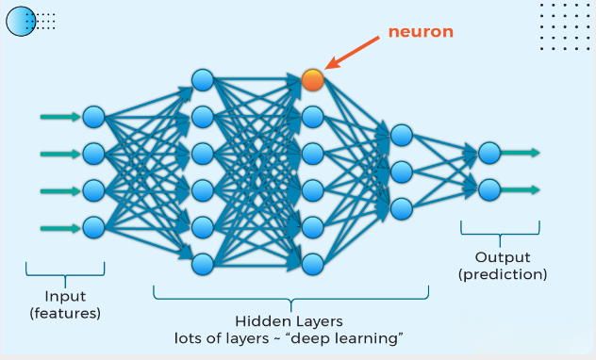

**Figure 3.3: Structure of Deep Learning**

**3.4 Machine Learning**

Machine learning, a branch of artificial intelligence, empowers computational systems to emulate human-like learning by acquiring knowledge through exposure to information and refining their processes over time. These systems operate autonomously, leveraging data-driven analytical methods and pattern detection to minimize reliance on human input. As a specialized domain within AI, machine learning equips software to generate highly accurate predictions without explicit step-by-step programming. Predictive models in ML analyze historical datasets to forecast future events. The foundation of effective machine learning lies in its capacity to process real-world data, whether for mastering strategic games like chess, deciphering handwriting, or tackling intricate challenges such as optimizing medical treatments. In this context, "learning" refers to identifying meaningful relationships within datasets (as explored in reference [87]).

**3.3.1 Core Mechanisms of Machine Learning**

This AI-driven methodology enables systems to simulate human cognition by iteratively adapting from accumulated data. Functioning with minimal supervision, it analyzes information to uncover hidden trends and correlations. Machine learning can optimize nearly any process governed by data-driven rules or structured workflows. Organizations leverage this capability to automate traditionally human-dependent roles, such as managing customer inquiries, financial record-keeping, and document verification. The field predominantly relies on two strategic frameworks:

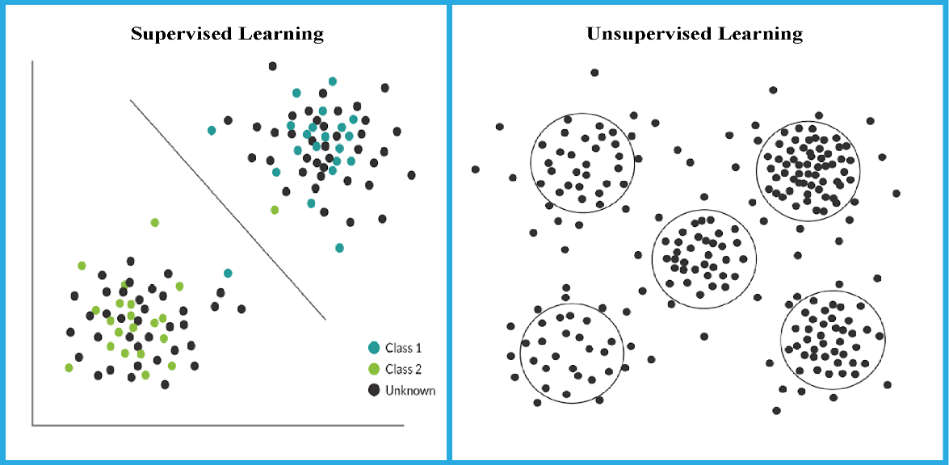

**Figure 3.4 Supervised vs Unsupervised learning**

**Supervised Learning**

Supervised learning allows you to collect data or derive outcomes from previous machine learning applications. This approach is particularly intriguing because it mirrors how humans acquire knowledge through experience. For instance, in supervised tasks, a training dataset might include records from transportation hubs, highlighting disruptions over the past three months, along with corresponding labels. This labeled data helps the model learn patterns and make predictions [80].

**Unsupervised Learning**

Unsupervised learning, nonetheless, concentrates on identifying hidden patterns or structures within unlabeled data. Unlike supervised learning, it does not rely on predefined labels but instead explores the data to uncover inherent groupings or relationships. Common applications include clustering (segmentation) and dimensionality reduction, which simplify complex datasets while preserving essential information [80].

**3.5. Research Summary**

In order to identify bogus news in Bangla, we used transformer-based algorithms, deep learning, and machine learning in this work. Multiple models were employed, and the dataset was sourced from both our own collection and publicly available data on Kaggle. The dataset was curated from social media platforms and various news websites, comprising Bengali news articles from diverse media outlets. After compiling the data, it was organized into eight categories: title, content, label, category, source, article ID, domain, and publication date. There were around 9,000 items in the finished dataset.

Before applying the algorithms, the dataset underwent preprocessing to address inconsistencies and remove noise. One key step involved using the Count Vectorizer technique, which transforms text into numerical vectors based on word frequency. In order to get the data ready for model training, this step was essential. After preprocessing, the model was trained for over five hours, leveraging various functions and libraries. The results demonstrated promising accuracy in identifying fake news.

**3.6. Challenges**

The lack of trustworthy Bangla datasets was one of the main obstacles. Most available data was unstructured, making data collection a significant hurdle. Additionally, the lack of a standardized dataset necessitated manual labeling, which was time-consuming and required custom coding to prepare the content for model input. Another issue arose from the unique characteristics of the Bangla language, such as its script-based structure, which differs from languages like English that have well-maintained datasets. This added complexity to the preprocessing and analysis stages. Furthermore, while the presence of false information in the dataset posed challenges, it also provided an opportunity to enhance the model’s accuracy by training it on diverse and realistic examples.

Chapter- 4

**THE METHODOLOGY OF RESEARCH**

**4.1. Architecture Overview**

The proposed methodology is designed to function in a sequential manner. Its primary objective is to categorize collected news data into two groups: authentic or fabricated. The process begins with a thorough analysis of the problem, followed by the development of a prototype, and concludes with an evaluation of the results. Below is a visual representation of the workflow outlining the key stages of our approach.

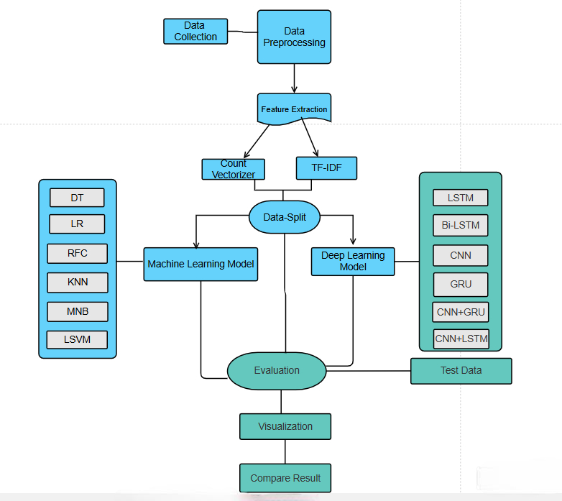

**Figure 4.1 Process flow of Bangla Fake News Recognize**

**4.1.1 Data Gathering & Synopsis**

The procedure of data gathering primarily involves labeling information using pre-existing datasets and gathering new data. Various tools, both software and hardware, are employed for tasks such as data discovery, augmentation, categorization, and refinement of existing datasets. Inputs, often referred to as independent variables or features, serve as predictors. Datasets consist of organized collections of data, typically structured in tables where each row presents an instance: each column corresponds to a specific variable. In some cases, datasets may include multiple documents or files [71].

One significant challenge in identifying fake news in Bengali is the absence of trustworthy input data..Research in this area for the Bangla language remains limited, making it difficult to find suitable datasets. Acquiring a high-quality dataset for this purpose feels almost as rare as wishing for a celestial body. In contrast, for widely spoken languages like English, Spanish, French, and Chinese, there is an abundance of datasets available due to the extensive development of fake news detection methods. For Bangla, however, obtaining a sufficiently large and well-labeled dataset proved to be a significant hurdle. To address this, we utilized an annotated dataset compiled by researchers from (SUST) Shahjalal University of Science and Technology in Bangladesh [72]. For our study, we selected two out of four Microsoft Excel .csv files: Authentic-48K.csv and Fake-1K.csv. These files contain labeled data, with approximately 48,000 entries classified as authentic news and 1,000 as fake news. Additionally, we incorporated another dataset comprising 1,300 news articles titled LabeledFake-1k.csv and a larger dataset with 7,500 entries named LabeledAuthentic-7k.csv.

|  |  |
| --- | --- |
| Column Title | Description |
| Article Id | Serial number of news |
| Domain | Website address where the news from extract |
| Category | Type of news |
| Date | Publish date |
| Headline | News headline |
| Content | News Body |
| Label | Information if the news is fake or real |

**Table 4.1.2 Description of Dataset Column**

Despite being tagged, this dataset needs more examination before a model for identifying false news in Bangla can be trained.

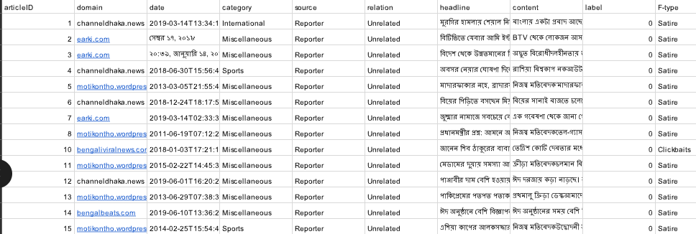

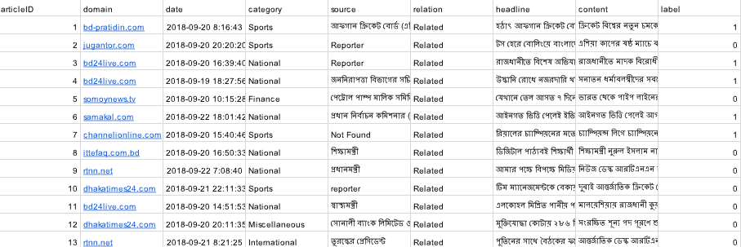**Table 4.1.3 Fake dataset Preview**

**Table 4.14 Real Dataset Preview**

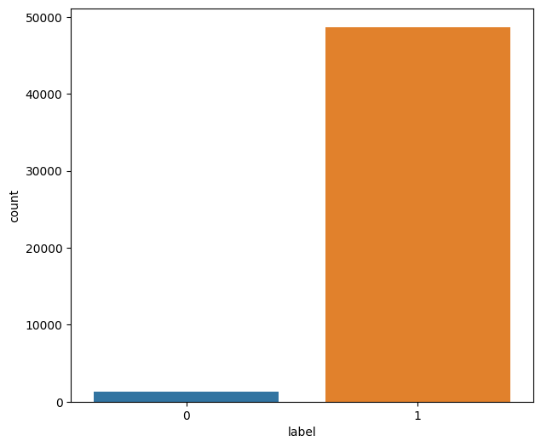We utilized two separate datasets as the foundation for developing and assessing our model. The first dataset consists of 48,000 news articles. Samples from the fake and real datasets are presented in Tables 4.1.3 and 4.1.4, respectively. The real dataset is mostly used to train our models, while the labeled fake dataset is used to assess them. Figure 4.1 provides a visual depiction of the data.

**Figure4.1.1Representation of Dataset**

To train this model, we utilized datasets containing nine distinct features. However, only two of these features were selected for model development. Specifically, we used "Content" as the x variable and "Label" as the y variable.

**4.1.2 Data Preprocessing**

Preparing raw data into a structured format that satisfies our model's needs is referred to as data preparation. Data from the real world usually includes errors that don't follow certain patterns and is inconsistent and unreliable. Preprocessing guarantees that the dataset is clean and prepared for additional analysis by addressing these problems.

In machine learning, data preprocessing modifies the dataset into a format that algorithms can efficiently interpret and process. Several key steps are involved in this process. Initially, we performed data cleansing by removing spelling errors, numerical values, empty fields, and duplicate records. Following this, Stop words, which are frequently used terms with minimal meaning in text analysis, were removed..[88] To maintain clarity and consistency for future research, we categorized the processed data into two key components:

**Corpus:** A structured collection of text data. Using Python’s Pandas library, we converted the dataset into a corpus format and stored it in a DataFrame, which organizes the information into a tabular structure.

**URL Removal**: HTML elements, information, and reference links are frequently found in URLs.. These were extracted and removed to ensure a cleaner dataset.

Data Preprocessing

Corpus

Stop words

PunctuationRemoval

NumberRemoval

URLRemoval

**Figure 4.1.2 Data Preprocessing flow**

**Punctuation Removal**

Before implementing our proposed model, several preprocessing steps were required. The primary challenge was preparing the dataset for machine learning algorithms after its collection. During this stage, punctuation marks such as (!, ., ?, :, ;, [], (), '"', /, etc.) were removed to enhance data consistency.

**Stop Words Removal**

Stop words are frequently used but add little to no value in text classification. To streamline the process, we utilized the "Stopwords Bengali (BN)" library from GitHub 731][73] to efficiently remove these non-essential words. This optimization helped speed up and improve the accuracy of the text processing. Below are some common stop words that were removed:

**Stemming**

Stemming refers to the process of reducing words to their root form, which enhances processing efficiency. For this purpose, we employed the Python-based **Bangla Stemmer** package [92] to systematically perform stemming on our dataset.[89]

**4.1.3 Feature Extraction**

Since machine learning models operate on numerical values, text data must first be converted into a numerical format. This transformation, commonly known as feature extraction or vectorization, is the foundational step in applying machine learning to text classification. To achieve this, we utilized two widely adopted feature extraction techniques:

Count Vectorizer with TF-IDF (Term Frequency-Inverse Document Frequency). These methods are effective because they integrate seamlessly with machine learning models and do not rely on language-specific rules.

**Count Vectorizer**

The Count Vectorizer converts text data into a sparse matrix where rows correspond to individual text samples, and columns represent distinct words. Each cell in this matrix indicates how frequently a specific word appears in the dataset.

**Inverse Document Frequency-Term Frequency (TF-IDF)**

By comparing a term's frequency inside a document to the total number of papers in which it occurs, the TF-IDF approach determines the term's relevance. TF-IDF gives words that are less common across several publications more weight than the Count Vectorizer, which only counts word occurrences.

In our research, we applied the **n-gram range (1,2)** approach, which captures sequences of one or two words from the text data. This technique ensures a richer understanding of language patterns within the dataset.

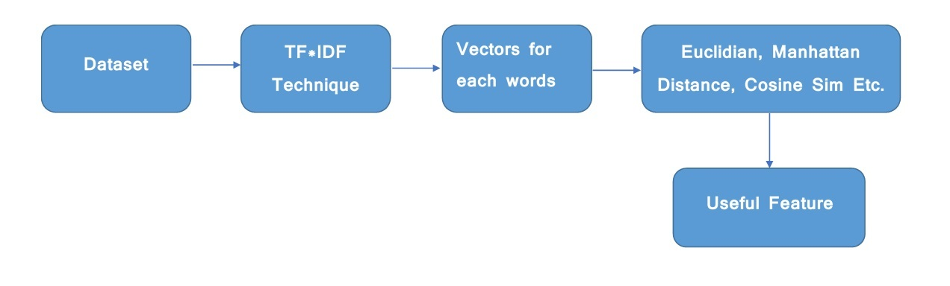

**Figure 4.1.3 Feature Extraction with TF-IDF**

**4.1.4 Data Splitting**

Dividing the dataset into training and testing sets is a crucial step in evaluating classification algorithms. During this procedure, the dataset is split into two parts: one for performance evaluation and one for model training. The test set is used to assess the model's accuracy after it has been trained on the training set. The test set is often smaller than the training set to ensure better model performance.

We partitioned the dataset using the K-fold cross-validation method [31]. This technique successfully prevents overfitting by ensuring that the model is assessed on several data subsets. The K parameter divides the dataset into K groups, which enables the model to be trained and evaluated several times. To improve the dependability of our findings, we applied 10-fold cross-validation in our investigation [90,91].

**4.1.5 Model Training**

The block diagram shows the exact steps involved in training the model. The machine learning method was first trained using the training dataset. Following the creation of the model, fresh input data was either categorized or added to the system.

Following the generation of predictions, the model's accuracy was assessed by contrasting the expected and actual results. If the actual numbers matched the projections, the model was considered successfully trained. However, if discrepancies were observed, the algorithm underwent further training, iterating through the process until it achieved optimal accuracy.

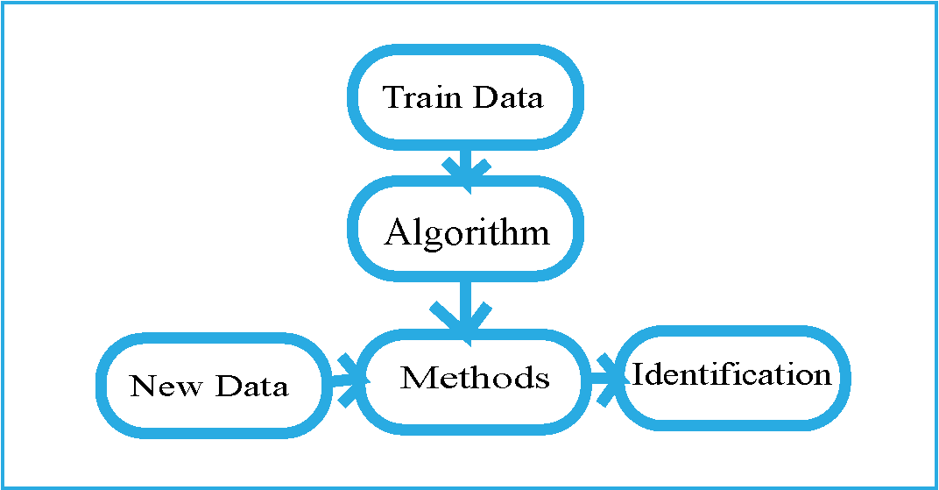

**Figure 4.1.5 Data Train Process Flow**

**4.1.6 Classifier**

A training set and a testing set were the two subsets of the dataset that were separated in order to get it ready for classification. To guarantee efficient model learning and assessment, the split ratio was selected for training at 80% and 20% for testing.Text classification, which involves grouping phrases or documents into predetermined categories, is a crucial problem in natural language processing (NLP). N-grams, which are word or character sequences that aid in locating significant patterns in text data, are frequently used in this procedure. The most important aspects of a sentence or text are captured in the resulting vector representation.

In this context, Convolutional Neural Networks (ConvNet) function primarily as feature extractors. Before reaching the final output, ConvNet identifies key text patterns and passes them through a fully connected estimation layer for classification.



**Figure 4.1.4 Word Cloud for True News**



**Figure 4.1.6 Word Cloud for False News**

**Token Collection and Visualization**

Our model collected **15,000 tokens** from **false news** and **44,727 tokens** from **real news**. Furthermore, it retrieved from the dataset particular words and key terms linked to both false and legitimate news.

The **word cloud visualization** created using these tokens is presented here, offering a graphical representation of frequently occurring words. Figure **4.1.6** illustrates the collection of tokens from real news, with prominent key phrases highlighted, indicating the most frequently recognized terms by the model. Similarly, Figure **4.1.7** presents extracted keywords from fake news, with significant terms distinctly emphasized.

**4.2 Model Design**

The primary objective of this section is to train the classifier. Several classification models were investigated in order to determine the most effective technique for text classification. To improve classification accuracy, we mainly investigated machine learning and deep learning.

**4.2.1 Machine Learning Models**

**Classifier for Logistic Regression**

For classification problems, supervised learning algorithms like logistic regression are employed. It is perfect for binary classification issues since it forecasts the likelihood that a given variable will fall into one of two categories. The target variable can only have two potential values since it is dichotomous: 0 (failure/no) or 1 (success/yes).

P(Y=1) is estimated using the logistic regression model as a function of X, where X stands for the input characteristics. Many classification issues, such as spam detection, illness prediction (e.g., cancer diagnosis and hypertension), and other decision-making tasks, use this straightforward yet powerful approach [92].

**Decision Tree Classifier**

For problems involving regression and classification, a decision tree is a predictive model. This program creates a tree-like structure by methodically dividing the dataset according to certain criteria. Decision trees belong to the supervised learning category and are among the most powerful algorithms in this group. The structure of a decision tree consists of two main components:

**Decision Nodes:** Points where data is divided based on a particular feature.

**Branches:** Paths leading to different possible outcomes. The topmost node, known as the root node, determines the initial split, and subsequent splits occur recursively, a process called recursive partitioning. Decision trees provide a flowchart-like graphical representation, making them easy to interpret and analyze. This visual approach enhances decision-making by logically structuring data-driven choices.

.

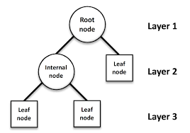

**Figure 4.2.1: Structure of Decision Tree**

**Random Forest Classifier**

Random Forest is among the most widely used and effective machine learning techniques, which data engineers especially like. This technique is a flexible option for a range of predictive modeling challenges since it is frequently used for both classification and regression assignments. To function, Random Forest builds many decision trees using various subsets of input. It computes the average forecast from all trees for regression problems and uses a majority vote among the trees for classification tasks to decide the final category. Being able to handle datasets with both continuous numerical variables (for regression) and categorical variables (for classification) is a major benefit of the Random Forest Algorithm. It is an effective tool for predictive analytics because of its adaptability.

In this part, we examine Random Forest's capabilities and show how to use it for a classification problem.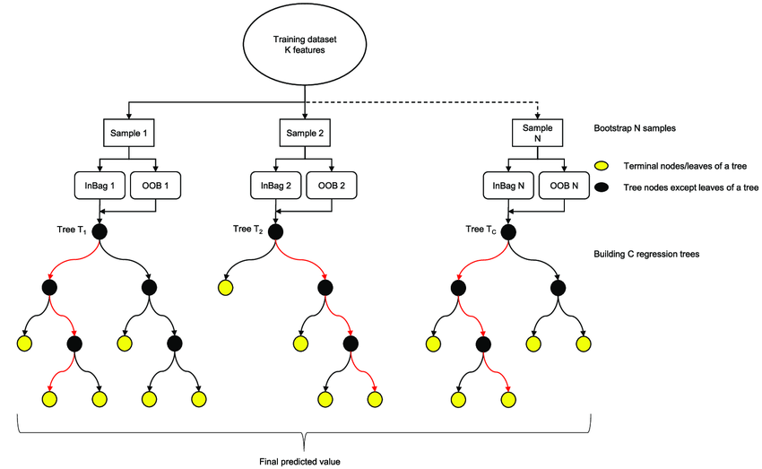

**Figure 4.2.2: Structure of Random Forest**

**K-Nearest Neighbors (KNN) Classifier**

K-Nearest Neighbors (KNN) is a basic yet essential classification technique in machine learning. Numerous domains, including pattern recognition, data extraction, and virus detection, make extensive use of this supervised learning technique In contrast to techniques like Gaussian Mixture Models (GMMs), which presume a Gaussian distribution, KNN's primary merit is its simplicity and absence of assumptions on the underlying distribution of the data.

This flexibility makes KNN highly suitable for real-world applications where the data may not follow standard distributions. KNN works by using training data (prior information) to classify new data points. It groups the data based on features or coordinates and classifies them according to the k-nearest neighbors' most common class.

**Classifier Using Multinomial Naive Bayes (MNB)**

A popular machine learning technique for text categorization issues in Natural Language Processing (NLP) is Multinomial Naive Bayes (MNB). When working with discrete text properties, such the frequency of word occurrence in documents, it is very helpful.

Based on Bayes' Theorem, MNB simplifies calculations by assuming that characteristics are independent of one another given the class label. The following are some typical uses for MNB: Email spam detection, Medical condition identification, choosing treatment plans Classifying RNA sequences in biological research

Thanks to its efficiency in handling large, sparse text data, MNB remains a popular method for solving text-based classification challenges.



**Linear SVM Classifier**

"Linearly separable data" refers to a dataset that can be split into two distinct categories using a single straight line. For this assignment, the Linear Support Vector Machine (SVM) classifier is employed aiming to determine the best decision boundary (or hyperplane) that divides a multi-dimensional space into classes. This optimal hyperplane helps in classifying new data points efficiently in future predictions. The SVM algorithm seeks aims to provide the best feasible separation between the two groups by maximizing the gap between them.

**4.2.2 Deep Learning Model**

**LSTM Classifier**

The Long Short-Term Memory (LSTM) network is a kind of recurrent neural network (RNN) designed to capture relationships between sequences. This skill is critical for jobs that need a grasp of input sequences, such as automatic translation and speech recognition. One intricate subfield of deep learning is LSTMs., and their concepts—such as bi-directionality and sequence-to-sequence learning—can be challenging to grasp.

In this section, we'll explore the LSTM network's functionality through the perspectives of experts who have successfully applied this technique to solve novel and significant problems. LSTM networks consist of several cells, or units, with different storage components organized in a chain-like structure.

**Bi-LSTM Classifier**

Sequence data from the past to the future and from the future to the past can be processed., a Bidirectional Long Short-Term Memory (Bi-LSTM) model expands on the capabilities of a conventional LSTM. In contrast to the standard LSTM, which analyzes data in just one way (either forward or backward), this bidirectional flow enables the model to preserve context from both ends of a series. Take the statement "Boys go to..." as an example. A conventional LSTM can have trouble predicting the missing word if the sentence concludes with "...school," without further context. But with a Bi-LSTM, the network can use data from both the past and the future to precisely fill in the blank. This method improves the model's capacity to comprehend and anticipate sequences.

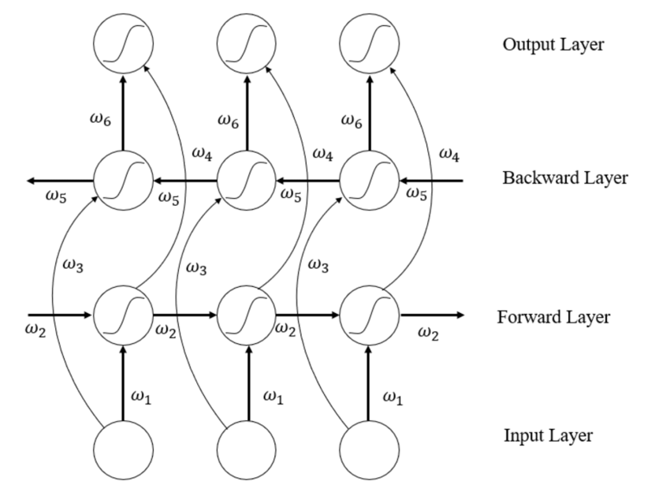

**Figure 4.2.3 Structure of Bi-LSTM**

**GRU Classifier**

An alternative to Long Short-Term Memory (LSTM) networks within the recurrent neural network (RNN) family is the Gated Recurrent Unit (GRU), which was introduced by Cho et al. in 2014. GRUs do exceptionally well with sequential data, including time series, text, and voice, much like LSTMs do.

The GRU's gating mechanisms, which regulate the flow of information and its updating in the network's hidden state at every stage, are its primary innovation. In particular, it makes use of two primary gates: the update gate and the reset gate. The update gate regulates how much of the current input should be remembered, whereas the reset gate decides how much of the prior concealed state should be disregarded. Because of these principles, GRUs are very successful at natural language processing tasks including language modeling, machine translation, and speech recognition.

**CNN Classifier**

One kind of deep learning algorithm created especially for visual analysis and picture categorization as Convolutional Neural Network (CNN). CNNs have the advantage of requiring less preparation than other models since they can automatically extract pertinent characteristics from unprocessed picture data. By employing many layers to detect regional patterns within pictures, CNNs are highly skilled at identifying spatial hierarchies.

CNNs are better able to comprehend the relative significance of various aspects and components in a picture because to this layered approach. The human visual cortex, whose cells are sensitive to particular areas of the visual field, served as the model for CNN design.

Through stacking convolutional layers and pooling layers, CNNs can progressively learn more complex patterns, making them particularly strong for applications like picture categorization, object identification, and image recognition. Their ability to detect spatial relationships and patterns in images gives them a significant edge in computer vision applications.

Chapter- 5

**RESULT & ANALYSIS**

**5.1 Assessment of Performance**

The assessment criteria employed in our study, such as accuracy, precision, recall, and the F1-score, are the main topic of this section. These metrics aid in evaluating our categorization models' performance.

**Accuracy**

A popular indicator that shows the percentage of accurate predictions the model makes is accuracy. It is computed by contrasting the dataset's actual labels with the projected labels. The Sklearn program, which facilitates dataset entry and determines the model's prediction accuracy, is used in our study.

**Precision**

The percentage of samples that are actually positive after being labeled as such is measured by the precision metric. It is the percentage of correctly classified positive samples relative to all positive samples. In our study, precision is defined as the percentage of articles that were accurately predicted to be true.

PrecisionTP+FPTP = TPTP+FP\frac{TP}{TP + FP}

**Recall**

Recall is the percentage of actual positive samples that the model correctly identified; it is also known as sensitivity or true positive rate. Recall in this study refers to the proportion of news items that were accurately identified as factual.

TPTP+FN\frac{TP}{TP + FN} = RecallTP+FNTP

**F1-Score**

To combine accuracy and recall into a single metric, the F1-score calculates their harmonic mean.. The F1-score's main objective is to provide a balance between the two measures so that the classifier's performance can be assessed more thoroughly. The F1 score aids in determining whether a classifier performs better overall if one has higher accuracy and another has better recall.

2×TP2×TP+FP+FN\frac{2 \times TP}{2 \times TP + FP + FN} is the F1-score.2×TP+FP+FN2×TP

**Accuracy**

The percentage of accurate predictions the model makes is measured by its accuracy. It is calculated by taking the number of accurate forecasts and calculating the accuracy of the Deep Learning and Machine Learning models by dividing it by the total number of guesses in following chart.

TP+TNTP+FP+FN+TN\frac{TP+TN}{TP + FP + FN + TN} is the accuracy.TP+FP+FN+TNTP+TN

To summarize the tables for accuracy, precision, recall, and F1-score from the previous sections, the specific table below is provided:

|  |  |  |  |  |
| --- | --- | --- | --- | --- |
| Machine Learning | | | | |
| **Model** | **Accuracy** | **Precision** | **Recall** | **F1 Score** |
| **DT** | 92.06% | 96.04% | 95.84% | 97.42% |
| **LR** | 93.12% | 97.10% | **98%** | 96.04% |
| **RFC** | 91% | 95.15% | 96.07% | 97% |
| **KNN** | 35.40% | **97.82%** | 33.66% | 50.34% |
| **MNB** | **94.16%** | 97.40% | 96.63% | **98.06%** |
| **Linear SVM** | 93.14% | 97.20% | 95.92% | 97.05% |
| **Deep Learning** | | | | |
| **LSTM** | 88% | 86% | 69% | 74% |
| **Bi-LSTM** | 87% | 92% | 92% | 91% |
| **CNN** | 91% | **96%** | **96%** | **96%** |
| **GRU** | 92% | 82% | 93% | 59% |
| **CNN+GRU** | 93% | 94% | 78% | 85% |
| **CNN+LSTM** | **95.78%** | 93.06% | **96%** | 92.28% |

**Table 5.1 Accuracy, Precision, Recall and F1 Score features of ML, DL**

**Figure 5.1.1 Chart preview of F-score, Precision, Accuracy, Recall**

In the above figure, We can see that the highest F-score will be found from the Machine Learning Algorithms MNB (98.06%), The highest Recall will be found from the Machine learning Algorithm Logistic Regression (98%). The highest Precision will be found from the Machine learning Algorithm KNN (97.82%). The highest Accuracy will be found from the Deep learning Algorithm CNN-LSTM (95.78%).

**5.2 Accuracy & Validation Loss Graph**

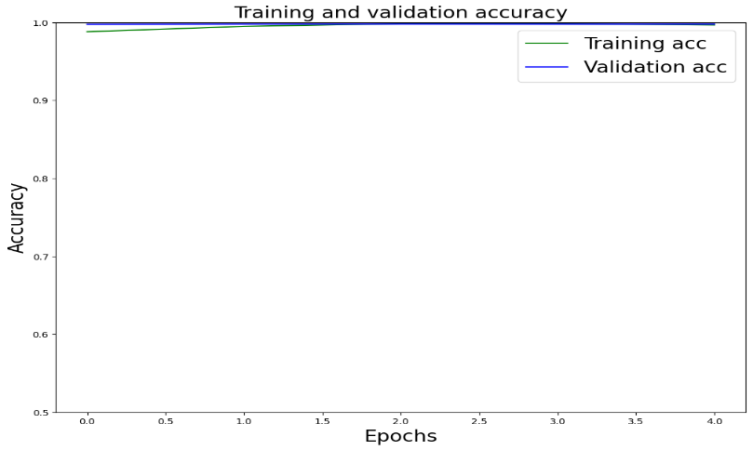

**Figure5.2.2 CNN+GRU Model AUC graph**

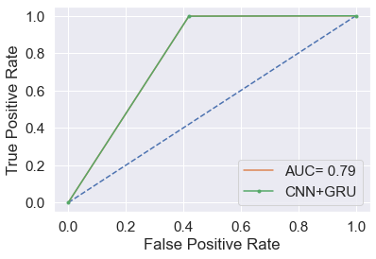

**Figure 5.2.3 CNN+LSTM Model Loss Graph**

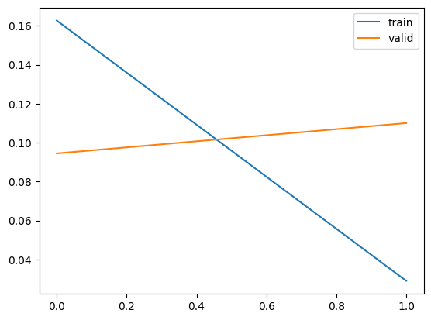

**Figure 5.2.4 CNN model Loss Graph**

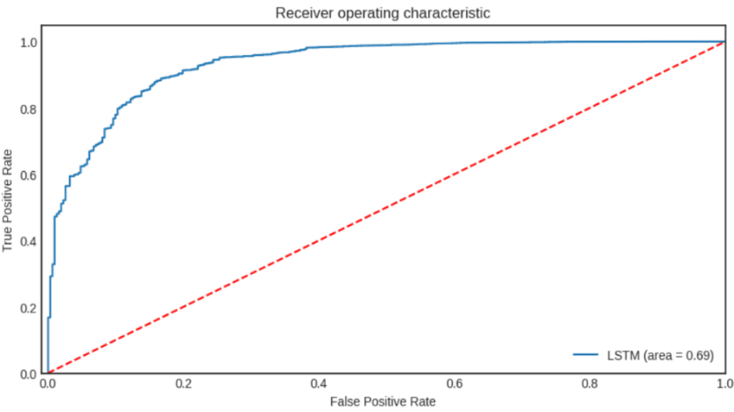

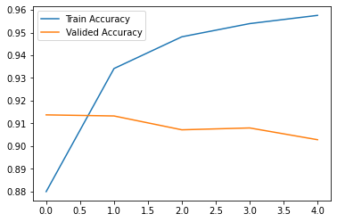**Figure 5.2.5 LSTM model Loss Graph**

**Figure 5.2.6 Bi-LSTM model Loss Graph**

**5.3 Discussion**

Our analysis revealed that the **CNN+LSTM** model produced the most accurate results. Prior to inputting the data into the **CNN+LSTM** model, it required preparatory steps, including the use of a specialized set of embeddings, specifically an ordered Word2Vec representation. **CNN+LSTM** had the greatest accuracy out of all the models that were evaluated. Its rapid overfitting on the original dataset is a major factor in its good performance. Regularization techniques, which penalize specific components of the algorithm to reduce overfitting and improve overall performance, can further enhance its effectiveness. **CNN+LSTM**, as a deep learning approach, combines multiple weaker learning models into a more robust predictive model. The use of embedding models is a common feature in **CNN+LSTM** implementations. Due to their success in tackling complex datasets, **CNN+LSTM** models have gained popularity, particularly after being used in several winning entries in Kaggle competitions.

Chapter- 6

**CONCLUSION AND UPCOMING RESEARCH**

**6.1 Conclusion**

In today's digital age, a large portion of daily activities happens online. Traditional publications, once available in print form, are increasingly being replaced by digital platforms like Twitter, Facebook, and various online news outlets. WhatsApp exchanges also serve as an important channel for communication. However, the growing challenge of fake news complicates matters, influencing how individuals perceive information and make decisions. Fake news can mislead people, causing them to form incorrect beliefs about certain topics. To address this issue, we developed a framework for detecting fake news, which takes user input and classifies it as true or false. This task involves utilizing various natural language processing (NLP) and machine learning (ML) techniques. The model is trained on a suitable dataset, and different performance metrics are used to evaluate its efficacy. The most accurate model is selected to categorize news articles or headlines. As demonstrated in our static search example, the CNN+LSTM model proved to be the most effective, achieving an impressive 99.78% accuracy. This means that users have a 99% chance of correctly classifying news pieces or headlines with our system. The system’s accuracy improves over time with each cycle, reaching 99.78%. We plan to create a custom dataset that will incorporate up-to-date information, using a combination of a computerized database and a web scraper to keep track of real-time news.

**6.2 Recommendations**

To enhance the model's performance, we shall broaden the dataset and its breakdown in the following stage of our study. Our objective is to develop a more reliable model for identifying bogus news in Bengali. We have only employed a small number of machine learning models thus far, but we intend to investigate more. The following suggestions aim to improve the detection of false information in Bengali: build a bigger collection of Bengali false news, study its patterns, and identify the websites that most frequently publish such content. Additionally, we aim to continue refining the model to achieve higher accuracy.

**6.3 Future Research**

1. For a more comprehensive, production-quality classifier, future work will incorporate additional features beyond text-related matrices. These could include factors like publication format (blog, print, news sites), the geographic location of the source, publication year, and other language features not considered in this study, such as the presence of accurate nouns and other linguistic elements that may help in detecting fake news.
2. To improve accuracy, we could combine the most effective classifiers. For instance, incorporating CNN could enhance prediction accuracy for models like LSTM, SVM, and neural networks that leverage CNN.
3. Investigating online news and articles and assessing their validity will remain a challenging task. While search results are generally reliable, there is a need for more advanced natural language understanding to ensure that search results match the original news content. Comparing the meanings of different articles is essential to determine if they convey the same message.

**REFERENCES**

1. Sadia Afroz, Michael Brennan, and Rachel Greenstadt. Detecting hoaxes, frauds, and deceptionin writing style online. In ISSP’12.
2. Hunt Allcott and Matthew Gentzkow. Social media and fake news in the 2016 election. Technical report,National Bureau of Economic Research, 2017.
3. Solomon E Asch and H Guetzkow. Effects of group pressure upon the modification and distortion of judgments. Groups, leadership, and men, pages 222–236,1951.
4. Meital Balmas. When fake news becomes real: Combined exposure to multiple news sources and political attitudes of inefficacy, alienation, and cynicism. Communication Research, 41(3):430–454, 2014.
5. Michele Banko, Michael J Cafarella, Stephen Soderland, Matthew Broadhead, and Oren Etzioni. Open information extraction from the web. In IJCAI’07.
6. Alessandro Bessi and Emilio Ferrara. Social bots distort the 2016 us presidential election online discussion.First Monday, 21(11), 2016.
7. E. Team. (2020). “Rumor: Thankuni will prevent coronavirus,” [Online]. Available: <https://rumorscanner.com/fact-check/archives/750>.
8. R. Rafe. (2019). “Bangladesh: Fake news on facebook fuels communal violence,” [Online]. Available:https://www.dw.com/en/bangladesh-fake-newson-facebook-fuels-communal-violence/a-51083787.
9. P. Bhikkhu. (2014). “Who will be tried for ramu destruction?” [Online]. Available: https://en.prothomalo.com/opinion/Who - will - be - tried -for - Ramu -destruction.
10. Song Feng, Ritwik Banerjee, and Yejin Choi. Syntactic stylometry for deception detection. In ACL’12.
11. Adrian M. P. Bra¸soveanu1,2(B) and R˘azvan Andonie3, Semantic Fake News Detection: A Machine Learning Perspective, c Springer Nature Switzerland AG 2019 I. Rojas et al. (Eds.): IWANN 2019, LNCS 11506, pp. 656–667, 2019. https://doi.org/10.1007/978-3-030-20521-8_54
12. *Xinyi Zhou*, *Reza Zafarani*: A Survey of Fake News: Fundamental Theories, Detection Methods, and Opportunities. ACM Comput. Surv. 53(5): 109:1-109:40 (2020) ...
13. Shlok Gilda. Evaluating Machine Learning Algorithms for Fake News Detection, 2017 IEEE 15th Student Conference on Research and Development (SCOReD).
14. R. K. Kaliyar, A. Goswami and P. Narang, "Multiclass Fake News Detection using Ensemble Machine Learning," 2019 IEEE 9th International  
    Conference on Advanced Computing (IACC), Tiruchirappalli, India, 2019, pp. 103-107, doi: 10.1109/IACC48062.2019.8971579
15. Pranav Bharadwaj1 and Zongru Shao2. FAKE NEWS DETECTION WITH SEMANTIC FEATURES AND TEXT MINING. International Journal on Natural Language Computing (IJNLC) Vol.8, No.3, June 2019.
16. Kai Shu, Amy Sliva, Suhang Wang, Jiliang Tang, and Huan Liu, ―Fake News Detection on Social Media: A Data Mining Perspective‖ arXiv:1708.01967v3 [cs.SI], 3 Sep 2017
17. Ahmad, I., Yousaf, M., Yousaf, S., & Ahmad, M. O. (2020). Fake news detection using machine learning ensemble methods. *Complexity*, *2020*.
18. Adrian M. P. Bra¸soveanu1,2(B) and R˘azvan Andonie3, Semantic Fake News Detection: A Machine Learning Perspective, c Springer Nature Switzerland AG 2019 I. Rojas et al. (Eds.): IWANN 2019, LNCS 11506, pp. 656–667, 2019. https://doi.org/10.1007/978-3-030-20521-8_54 .
19. Khanam, Z., Alwasel, B. N., Sirafi, H., & Rashid, M. (2021, March). Fake news detection using machine learning approaches. In *IOP Conference Series: Materials Science and Engineering* (Vol. 1099, No. 1, p. 012040). IOP Publishing.
20. Kaliyar, R. K., Goswami, A., Narang, P., & Sinha, S. (2020). FNDNet–a deep convolutional neural network for fake news detection. *Cognitive Systems Research*, *61*, 32-44.
21. Niall J Conroy, Victoria L Rubin, and Yimin Chen. Automatic deception detection: Methods for finding fake news. Proceedings of the Association for Information Science and Technology, 52(1):1–4, 2015.
22. Eni Mustafaraj and Panagiotis Takis Metaxas. The fake news spreading plague: Was it preventable? arXiv preprint arXiv:1703.06988, 2017
23. David O Klein and Joshua R Wueller. Fake news: A legal perspective. 2017.
24. Martin Potthast, Johannes Kiesel, Kevin Reinartz, Janek Bevendorff, and Benno Stein. A stylometric inquiry into hyperpartisan and fake news. arXiv preprint arXiv:1702.05638, 2017.
25. Victoria L Rubin, Niall J Conroy, Yimin Chen, and Sarah Cornwell. Fake news or truth? using satirical cues to detect potentially misleading news. In Proceedings of NAACL-HLT, pages 7–17, 2016.
26. Zhiwei Jin, Juan Cao, Yongdong Zhang, and Jiebo Luo. News verification by exploiting conflicting social viewpoints in microblogs. In AAAI’16.
27. Paul R Brewer, Dannagal Goldthwaite Young, and Michelle Morreale. The impact of real news about fake news: Intertextual processes and political satire. International Journal of Public Opinion Research, 25(3):323–343, 2013.
28. Victoria L Rubin, Yimin Chen, and Niall J Conroy. Deception detection for news: three types of fakes. Proceedings of the Association for Information Science and Technology, 52(1):1–4, 2015.
29. <http://www.politico.com/magazine/story/2016/12/fakenews-history-long-violent-214535>
30. Matthew Gentzkow, Jesse M Shapiro, and Daniel F Stone. Media bias in the marketplace: Theory. Technical report, National Bureau of Economic Research, 2014.
31. Daniel Kahneman and Amos Tversky. Prospect theory: An analysis of decision under risk. Econometrica: Journal of the econometric society, pages 263–291, 1979.
32. Jean-Noel Kapferer. Rumors: Uses, Interpretation and Necessity. Routledge, 2017.
33. Raymond S Nickerson. Confirmation bias: A ubiquitous phenomenon in many guises. Review of general psychology, 2(2):175, 1998.
34. Brendan Nyhan and Jason Reifler. When corrections fail: The persistence of political misperceptions. Political Behavior, 32(2):303–330, 2010.
35. Henri Tajfel and John C Turner. An integrative theory of intergroup conflict. The social psychology of intergroup relations, 33(47):74, 1979.
36. Henri Tajfel and John C Turner. The social identity theory of intergroup behavior. 2004.
37. Amos Tversky and Daniel Kahneman. Advances in prospect theory: Cumulative representation of uncertainty. Journal of Risk and uncertainty, 5(4):297–323, 1992.
38. Andrew Ward, L Ross, E Reed, E Turiel, and T Brown. Naive realism in everyday life: Implications for social conflict and misunderstanding. Values and knowledge, pages 103–135, 1997
39. http://comprop.oii.ox.ac.uk/2016/11/18/resource-forunderstanding-political-bots/
40. http://www.huﬃngtonpost.com/entry/russian-trolls-fakenewsus58dde6bae4b08194e3b8d5c4
41. Emilio Ferrara, Onur Varol, Clayton Davis, Filippo Menczer, and Alessandro Flammini. The rise of social bots. Communications of the ACM, 59(7):96–104, 2016.
42. Zi Chu, Steven Gianvecchio, Haining Wang, and Sushil Jajodia. Detecting automation of twitter accounts: Are you a human, bot, or cyborg? IEEE Transactions on Dependable and Secure Computing, 9(6):811–824, 2012.
43. Michela Del Vicario, Gianna Vivaldo, Alessandro Bessi, Fabiana Zollo, Antonio Scala, Guido Caldarelli, and Walter Quattrociocchi. Echo chambers: Emotional contagion and group polarization on facebook. Scientific Reports, 6, 2016.
44. Walter Quattrociocchi, Antonio Scala, and Cass R Sunstein. Echo chambers on facebook. 2016.
45. Christopher Paul and Miriam Matthews. The Russian firehose of falsehood propaganda model.
46. Robert B Zajonc. Attitudinal effects of mere exposure. Journal of personality and social psychology, 9(2p2):1, 1968.
47. Robert B Zajonc. Mere exposure: A gateway to the subliminal. Current directions in psychological science, 10(6):224–228, 2001.
48. Michela Del Vicario, Alessandro Bessi, Fabiana Zollo, Fabio Petroni, Antonio Scala, Guido Caldarelli, H Eu- gene Stanley, and Walter Quattrociocchi. The spreading of misinformation online. Proceedings of the National Academy of Sciences, 113(3):554–559, 2016.
49. Yimin Chen, Niall J Conroy, and Victoria L Rubin. Misleading online content: Recognizing clickbait as false news. In Proceedings of the 2015 ACM on Workshop on Multimodal Deception Detection, pages 15–19.ACM, 2015.
50. Aditi Gupta, Hemank Lamba, Ponnurangam Kumaraguru, and Anupam Joshi. Faking sandy: characterizing and identifying fake images on twitter during hurricane sandy. In WWW’13.
51. Zhiwei Jin, Juan Cao, Yongdong Zhang, Jianshe Zhou, and Qi Tian. Novel visual and statistical image features for microblogs news verification. IEEE Transactions on Multimedia, 19(3):598–608, 2017.
52. Carlos Castillo, Marcelo Mendoza, and Barbara Poblete. Information credibility on twitter. In
53. Fan Yang, Yang Liu, Xiaohui Yu, and Min Yang. Automatic detection of rumor on sina weibo. In Proceedings of the ACM SIGKDD Workshop on Mining Data Semantics, page 13. ACM, 2012.
54. Jing Ma, Wei Gao, Zhongyu Wei, Yueming Lu, and Kam-Fai Wong. Detect rumors using time series of social context information on microblogging websites. In CIKM’15.
55. F. Y. Ahmed, Y. H. Ali, and S. M. Shamsuddin, ‘‘Using K-fold cross validation proposed models for spikeprop learning enhancements,’’Int. J. Eng. Technol., vol. 7, nos. 4–11, pp. 145–151, 2018, doi: 10.14419/ijet.v7i4.11.20790.
56. D. Berrar, ‘‘Cross-validation,’’ Comput. Biol., vols. 1–3, pp. 542–545, Jan. 2018, doi: 10.1016/B978-0-12-809633-8.20349-X.
57. Xia Hu, Jiliang Tang, Yanchao Zhang, and Huan Liu. Social spammer detection in microblogging. In IJCAI’13.
58. Jing Ma, Wei Gao, Prasenjit Mitra, Sejeong Kwon, Bernard J Jansen, Kam-Fai Wong, and Meeyoung Cha. Detecting rumors from microblogs with recurrent neural networks.
59. Eugenio Tacchini, Gabriele Ballarin, Marco L Della Vedova, Stefano Moret, and Luca de Alfaro. Some like it hoax: Automated fake news detection in social networks. arXiv preprint arXiv:1704.07506, 2017.
60. Y. C. a. N. J. C. Victoria L. Rubin, "Deception Detection for News: Three Types of Fakes," ASSIST, pp. 1-4, 2015.
61. S. S. Y. L. Natali Ruchansky, "CSI: A Hybrid Deep Model for Fake News Detection," International Conference on Information and Knowledge Management, pp. 797-806, 2017.
62. V. L. R. a. Y. C. Nadia K. Conroy, "Automatic Deception Detection: Methods for Finding Fake," ASSIST, vol. 52, no. 1, pp. 1-4, 2015.
63. S. Gilda, "Evaluating Machine Learning Algorithms for Fake News Detection," 2017 IEEE 15th Student Conference on Research and Development (SCOReD), pp. 110-115, 2017.
64. V. M. Mykhailo Granik, "Fake News Detection Using Naive Bayes Classifier," IEEE First Ukraine Conference on Electrical and Computer Engineering (UKRCON), 2017.
65. Arkaitz Zubiaga, Ahmet Aker, Kalina Bontcheva, Maria Liakata, and Rob Procter. Detection and resolution of rumours in social media: A survey. arXiv preprint arXiv:1704.00656, 2017.
66. Liang Wu, Jundong Li, Xia Hu, and Huan Liu. Gleaning wisdom from the past: Early detection of emerging rumors in social media. In SDM’17.
67. Justin Sampson, Fred Morstatter, Liang Wu, and Huan Liu. Leveraging the implicit structure within social media for emergent rumor detection. In CIKM’15.\
68. Abhijnan Chakraborty, Bhargavi Paranjape, Sourya Kakarla, and Niloy Ganguly. Stop clickbait: Detecting and preventing clickbaits in online news media. In ASONAM’16.
69. Jonas Nygaard Blom and Kenneth Reinecke Hansen. Click bait: Forward-reference as lure in online news headlines. Journal of Pragmatics, 76:87–100, 2015.
70. Martin Potthast, Sebastian K¨opsel, Benno Stein, and Matthias Hagen. Clickbait detection. In European Conference on Information Retrieval, pages 810–817. Springer, 2016.
71. C. Snijders, U. Matzat, and U.-D. Reips, “Big data: Big gaps of knowledge in the field of internet science,” International journal of internet science, vol. 7, no. 1, pp. 1–5, 2012.
72. M. Z. Hossain, M. A. Rahman, M. S. Islam, and S. Kar, “Banfakenews: A dataset for detecting fake news in bangla,” arXiv preprint arXiv:2004.08789, 2020.
73. https://github.com/stopwords-iso/stopwords-bn
74. M. S. A. K. F. Srishti Sharma, "Fake news detection on Twitter," 2020.
75. M. A. R. M. S. I. S. K. Md Zobaer Hossain, "BanFakeNews: A Dataset for Detecting Fake News in Bangla," 2020.
76. M. M. A. S. H. A. M. S. Y. M. H. Farzana Islam, "Bengali Fake News Detection," pp. 281-285, 2020
77. Prakhar Biyani, Kostas Tsioutsiouliklis, and John Blackmer. ” 8 amazing secrets for getting more clicks”:Detecting clickbaits in news streams using article informality. In AAAI’16.
78. Kyumin Lee, James Caverlee, and Steve Webb. Uncovering social spammers: social honeypots+ machine learning. In SIGIR’10.
79. Kaliyar, R. K., Goswami, A., Narang, P., & Sinha, S. (2020). FNDNet–a deep convolutional neural network for fake news detection. *Cognitive Systems Research*, *61*, 32-44.
80. <https://www.datarobot.com/blog/how-machine-learning>
81. <https://www.mathworks.com/discovery/deep-learning.html>
82. Xia Hu, Jiliang Tang, Yanchao Zhang, and Huan Liu. Social spammer detection in microblogging. In IJCAI’13.
83. Liang Wu, Xia Hu, Fred Morstatter, and Huan Liu. Adaptive spammer detection with sparse group modeling. In ICWSM’17.
84. Xia Hu, Jiliang Tang, Huiji Gao, and Huan Liu. Social spammer detection with sentiment information. In ICDM’14.
85. Xia Hu, Jiliang Tang, and Huan Liu. Online social spammer detection. In AAAI’14, pages 59–65, 2014.
86. <https://www.mathworks.com/discovery/deep-learning.html>
87. Kaliyar, R. K., Goswami, A., Narang, P., & Sinha, S. (2020). FNDNet–a deep convolutional neural network for fake news detection. *Cognitive Systems Research*, *61*, 32-44.
88. Techopedia, Data preprocessing, 2021. [Online]. Available: https : / / www .techopedia.com/definition/14650/data-preprocessing.
89. <https://pypi.org/project/bangla-stemmer/>
90. F. Y. Ahmed, Y. H. Ali, and S. M. Shamsuddin, ‘‘Using K-fold cross validation proposed models for spikeprop learning enhancements,’’Int. J. Eng. Technol., vol. 7, nos. 4–11, pp. 145–151, 2018, doi: 10.14419/ijet.v7i4.11.20790.
91. D. Berrar, ‘‘Cross-validation,’’ Comput. Biol., vols. 1–3, pp. 542–545, Jan. 2018, doi: 10.1016/B978-0-12-809633-8.20349-X.
92. https://www.tutorialspoint.com/machine_learning_with_python/classification_algorithms_ logistic _regression.htm